1. **Apache poi API –** is an API which is a collection of different java libraries.
2. These libraries gives the facility to read , write and manipulate different Microsoft files such as excel sheet, power point and word files.
3. Apache poi is having mainly four interfaces especially when you're working with excel file . These are the four interfaces- we use –
4. workbook interface ,
5. sheet interface
6. row and
7. cell

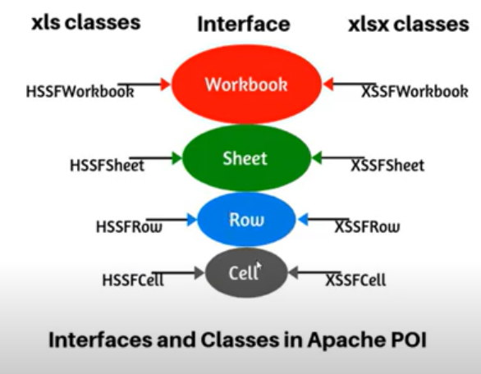

**the hierarchy of the excel--**

**Excel file** contains a workbook. the workbook contains the multiple sheets, every sheet contains a multiple rows and each row contains a multiple cells. so this is the hierarchy of the excel and  these interfaces have implemented by using different classes.

**Reading data from excel using Apache poi API and print in the console**

**There are many ways to read data from Excel file.**

1. Using a for loop method
2. Using Iterator
3. Using workbookFactory **class and its create static method**

**Steps 1) using for loop**

1)Create a maven project and dependencies in POM.xml file / java project and add jar files

1. Create a folder like data file and a file like TestData and then add some data in Excel file and save it.

To read the data we need FileInputStream class which will create a stream to this file and we can read the data

First we get the location of the file then I need to get the sheet then I need

to get the rows and then finally you can read the data from the cells.

1. First we get the location of the file and we refer that file by using file input stream .so that we are going to open the file in the reading mode then we get the workbook from the file.
2. All the classes like access of workbook, access of worksheet row ,xssf row excessive cell all the classes are present in the same package. So instead of specifying each and every class I say star

Like this [import.org.apache.poi.xssf.usermodel.*;]and then we need to add this exception

17:46

so from that file

17:48

we open the stream and we got the

17:50

workbook from the file so once we get

17:52

the workbook

17:53

from that workbook we have to get the

17:55

sheet so workbook

17:57

dot there is a method called get sheet

18:00

[Applause]

18:02

workbook dot get sheet so this

18:05

particular method

18:06

uh will get the sheet so we have two

18:09

methods are available so when i say get

18:11

sheet

18:12

we have to specify the name of the sheet

18:15

and this will

18:15

return the sheet object so we have to

18:18

create

18:19

uh excesses of sheet i say sheet equal

18:22

to

18:23

and this is again from apache pi

18:26

so from the workbook i extracted the

18:28

sheet and

18:29

referring that sheet with the object so

18:32

if you still want to like if you want to

18:35

pass an index we have one more method

18:37

that is for example you can write the

18:39

same statement like this

18:42

instead of get sheet method you can use

18:45

get sheet enter

18:48

so in that case you have to pass index

18:50

number so index is always start from

18:52

zero so either you can use the sheet

18:54

name or

18:55

you can use index name so now we got the

18:59

sheet from the workbook

19:00

so once we get the sheet now the sheet

19:03

contains a

19:04

rows as well as cells now we have to

19:06

read them

19:07

so first method am going to show you is

19:10

using

19:11

for loop okay using for loop how we can

19:14

read the data

19:16

from the sheet all the rows and columns

19:19

so to do that we need to find out how

19:22

many rows we have how many columns we

19:24

How to Read Data from Excel in java ?

1) How to add Excel Libraries in the project

2) How to create functions to get data

3) How to call functions from different class

4) How to work with .xlsx and .xls formats

Steps -

1) Create a java maven project and add dependencies in pom.xml--

a) selenium-java

b)Apach poi-ooxml

c)Apach poi

2) Create a package and name "utils" in src/test/java and I will keep all the Excel reading and writing

classes in this utils package and create a class name like ExcelUtils.

3) Create a Excel file and add some data

4) Create a function to get Row Count

5) create a Folder in the project So go the project folder and right click and create a folder and

I will name the folder like data and Inside the folder I will be created a Excel file.

So go to the Location of this Folder > right click > Properties > go the Location > click on location >

then See the folder names "data" and then create a Excel file to right click new >

Excel [go to Google WPS for MS office ]

So NAme the Excel workbook like "TestData". And Add some data in the Excel sheet.

6)create functions to get data -

public void getRowCount() {

String projDir =System.getProperty("user.dir");

System.out.println( projDir);

String excelPath = ("./data/TestData.xlsx");

}